(1) 1-G-Coin Problem
Started on | Tuesday, 19 August 2025, 12:07 PM
State | Finished
Completed on | Tuesday, 19 August 2025, 12:28 PM
Time taken | 20 mins 28 secs
Marks | 1.00/1.00
Grade | 10.00 out of 10.00 (100%)

Question 1
Correct
Mark 1.00 out of 1.00
Flag question
Question text
Write a program to take value V and we want to make change for V Rs, and we have infinite supply of each of the denominations in Indian currency, i.e., we have infinite supply of { 1, 2, 5, 10, 20, 50, 100, 500, 1000} valued coins/notes, what is the minimum number of coins and/or notes needed to make the change.
Input Format:
Take an integer from stdin.
Output Format:
print the integer which is change of the number.
Example Input :
64
Output:
4
Explanaton:
We need a 50 Rs note and a 10 Rs note and two 2 rupee coins.

Answer:(penalty regime: 0 %)
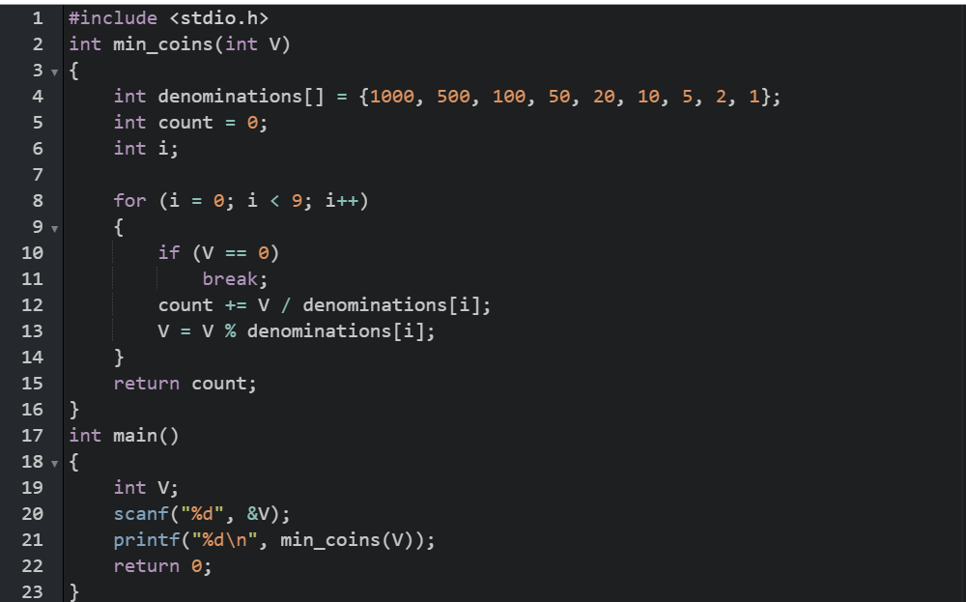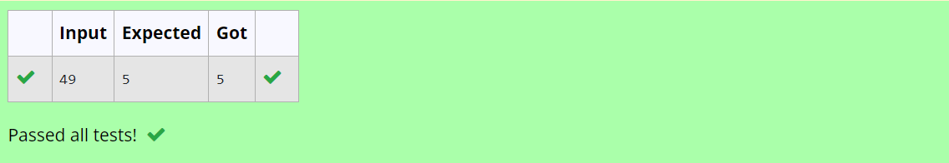
(2) Assume you are an awesome parent and want to give your children some cookies. But, you should give each child at most one cookie.
Each child i has a greed factor g[i], which is the minimum size of a cookie that the child will be content with; and each cookie j has a size s[j]. If s[j] >= g[i], we can assign the cookie j to the child i, and the child i will be content. Your goal is to maximize the number of your content children and output the maximum number.
Example 1:
Input:
3
1 2 3
2
1 1
Output:
1
Explanation: You have 3 children and 2 cookies. The greed factors of 3 children are 1, 2, 3.
And even though you have 2 cookies, since their size is both 1, you could only make the child whose greed factor is 1 content.
You need to output 1.
Constraints:
1 <= g.length <= 3 * 10^4
0 <= s.length <= 3 * 10^4
1 <= g[i], s[j] <= 2^31 - 1

Answer:(penalty regime: 0 %)
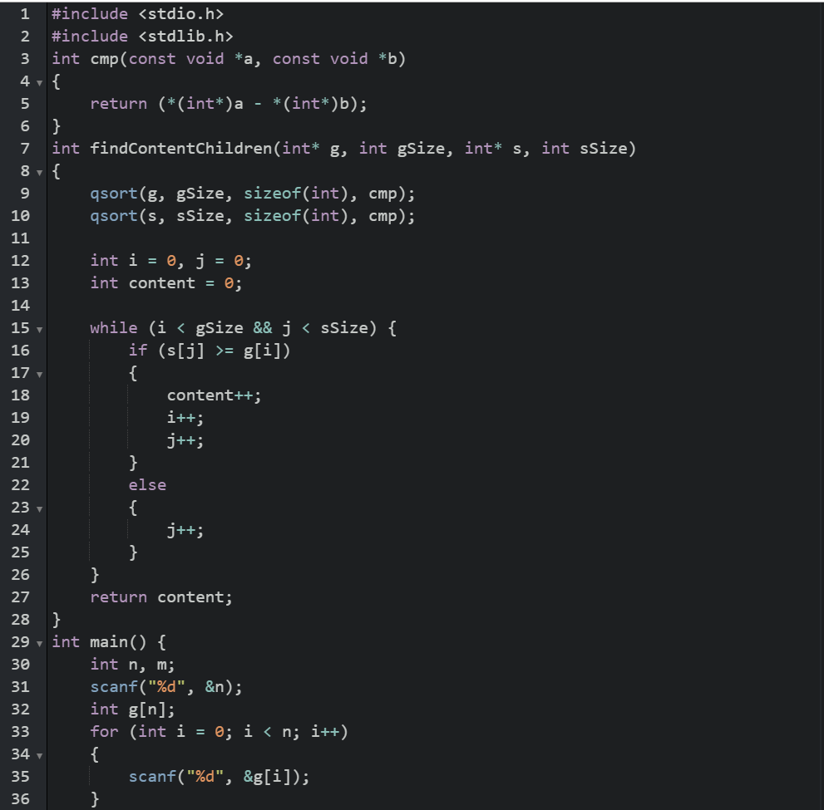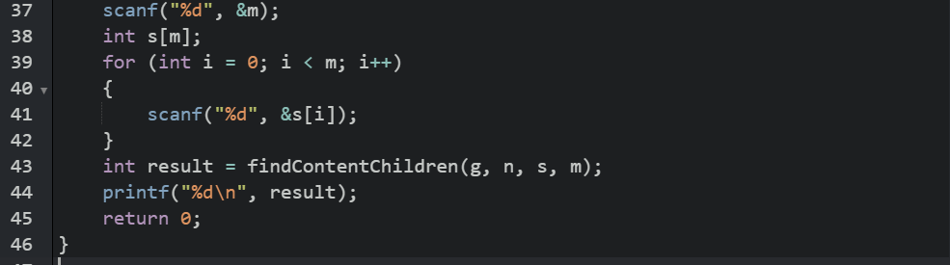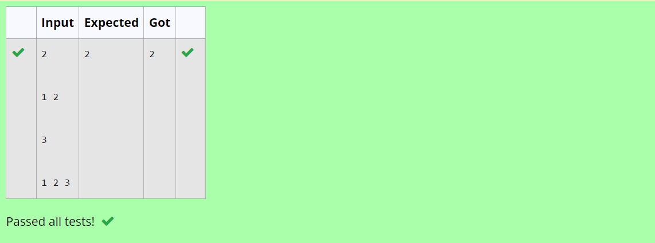
(3) 3-G-Burger Problem
Started on | Thursday, 28 August 2025, 9:05 AM
State | Finished
Completed on | Thursday, 28 August 2025, 9:05 AM
Time taken | 18 secs
Marks | 1.00/1.00
Grade | 10.00 out of 10.00 (100%)

Question 1
Correct
Mark 1.00 out of 1.00
Flag question
Question text
A person needs to eat burgers. Each burger contains a count of calorie. After eating the burger, the person needs to run a distance to burn out his calories.
If he has eaten i burgers with c calories each, then he has to run at least 3^{i} * c kilometers to burn out the calories. For example, if he ate 3
burgers with the count of calorie in the order: [1, 3, 2], the kilometers he needs to run are (3⁰ * 1) + (3¹ * 3) + (3² * 2) = 1 + 9 + 18 = 28.
But this is not the minimum, so need to try out other orders of consumption and choose the minimum value. Determine the minimum distance
he needs to run. Note: He can eat burger in any order and use an efficient sorting algorithm.Apply greedy approach to solve the problem.
Input Format
First Line contains the number of burgers
Second line contains calories of each burger which is n space-separate integers
Output Format
Print: Minimum number of kilometers needed to run to burn out the calories
Sample Input
3
5 10 7
Sample Output
76

For example:
Test | Input | Result
Test Case 1 | 3  1 3 2 | 18
Answer:(penalty regime: 0 %)

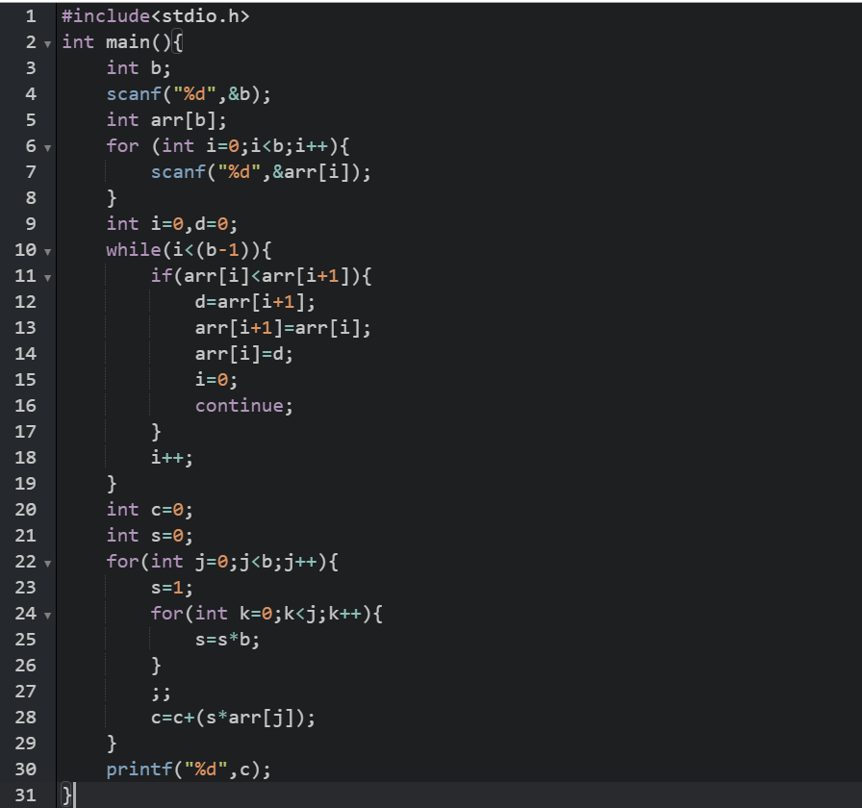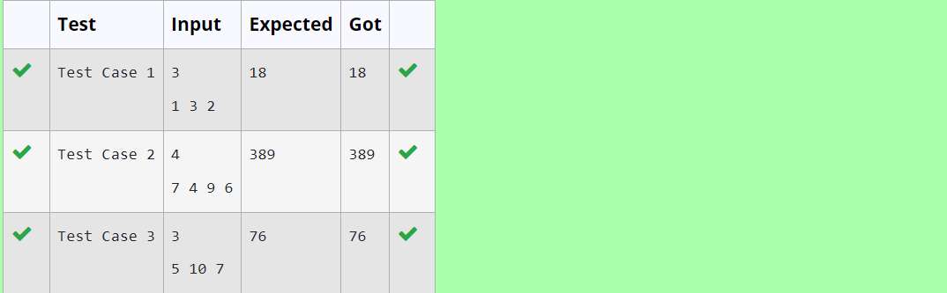
(4) 4-G-Array Sum max problem
Started on | Tuesday, 19 August 2025, 12:21 PM
State | Finished
Completed on | Tuesday, 19 August 2025, 12:28 PM
Time taken | 7 mins 40 secs
Marks | 1.00/1.00
Grade | 10.00 out of 10.00 (100%)

Question 1
Correct
Mark 1.00 out of 1.00
Flag question
Question text
Given an array of N integer, we have to maximize the sum of arr[i] * i, where i is the index of the element (i = 0, 1, 2, ..., N).Write an algorithm based on Greedy technique with a Complexity O(nlogn).
Input Format:
First line specifies the number of elements-n
The next n lines contain the array elements.
Output Format:
Maximum Array Sum to be printed.
Sample Input:
5
2 5 3 4 0
Sample output:
40

Answer:(penalty regime: 0 %)
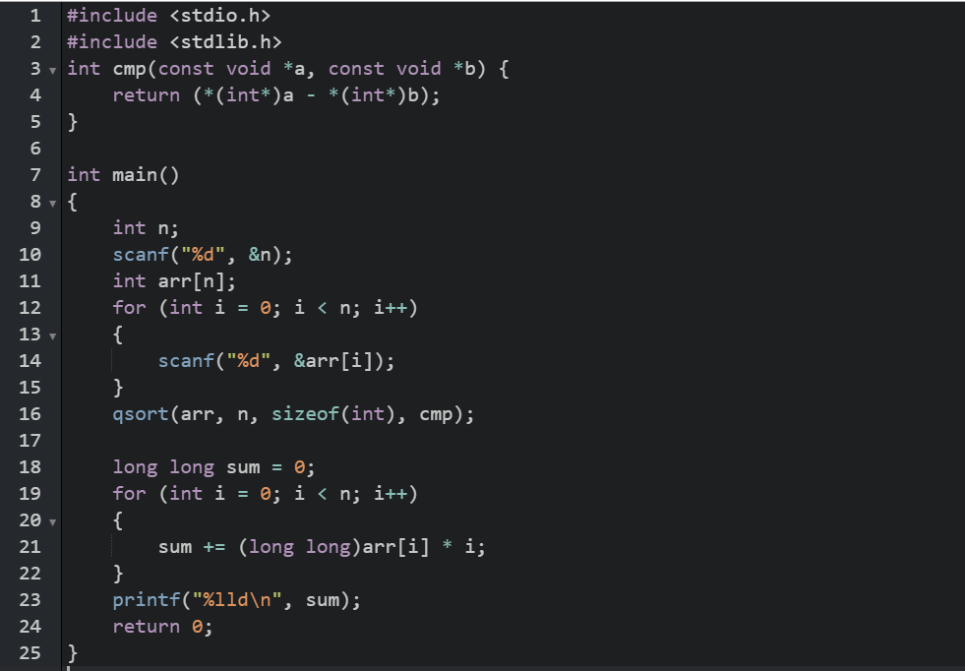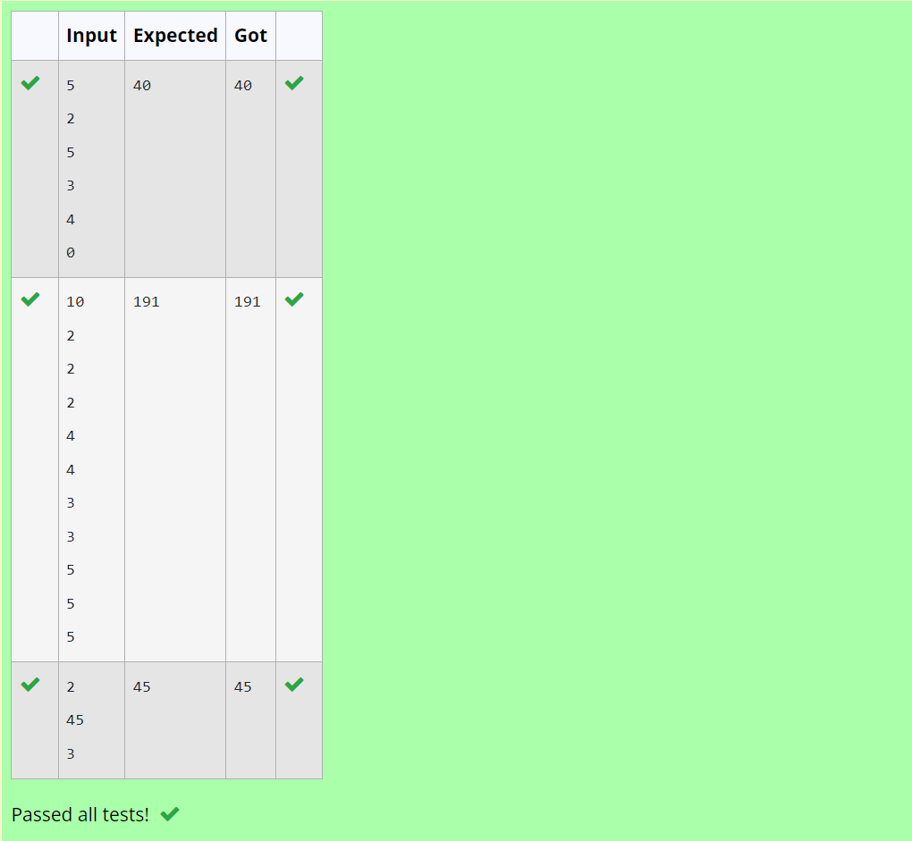
(5)5-G-Product of Array elements-Minimum
Started on | Tuesday, 19 August 2025, 12:22 PM
State | Finished
Completed on | Tuesday, 19 August 2025, 12:29 PM
Time taken | 7 mins 16 secs
Marks | 1.00/1.00
Grade | 10.00 out of 10.00 (100%)

Question 1
Correct
Mark 1.00 out of 1.00
Flag question
Question text
Given two arrays array_One[] and array_Two[] of same size N. We need to first rearrange the arrays such that the sum of the product of pairs( 1 element from each) is minimum. That is SUM (A[i] * B[i]) for all i is minimum.
For example:
Input | Result
3  1  2  3  4  5  6 | 28
Answer:(penalty regime: 0 %)
